**Course code: CSC-283**

**Lab Report: 04**

**Submitted To**

Tanzina Tasnim Bithi

Department of Computer, Science and Engineering

**Submitted By**

Name: Md.Pranto Ali

ID: 23303101

Program: BCSE

Section: A

Semester: Fall 2024

Submission date: Teacher signature

1. **Defining Member Function:**

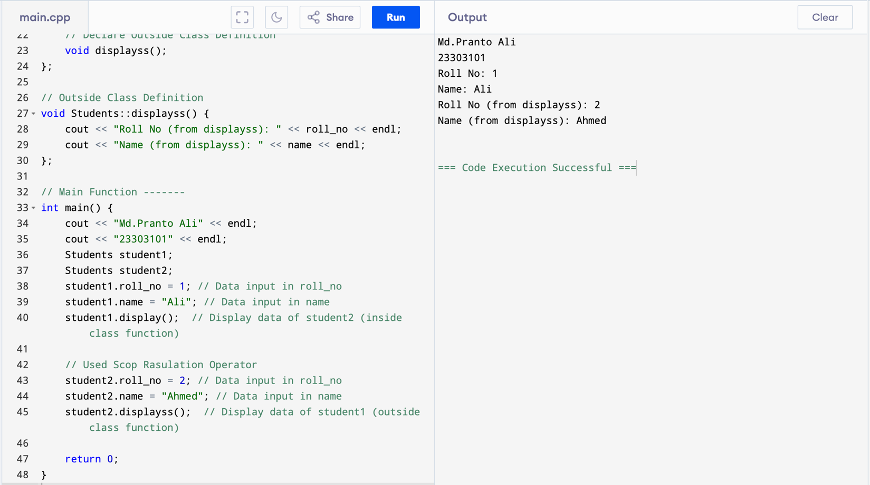

1. **Factorial of a number using recursion**
2. **Program With Class:**

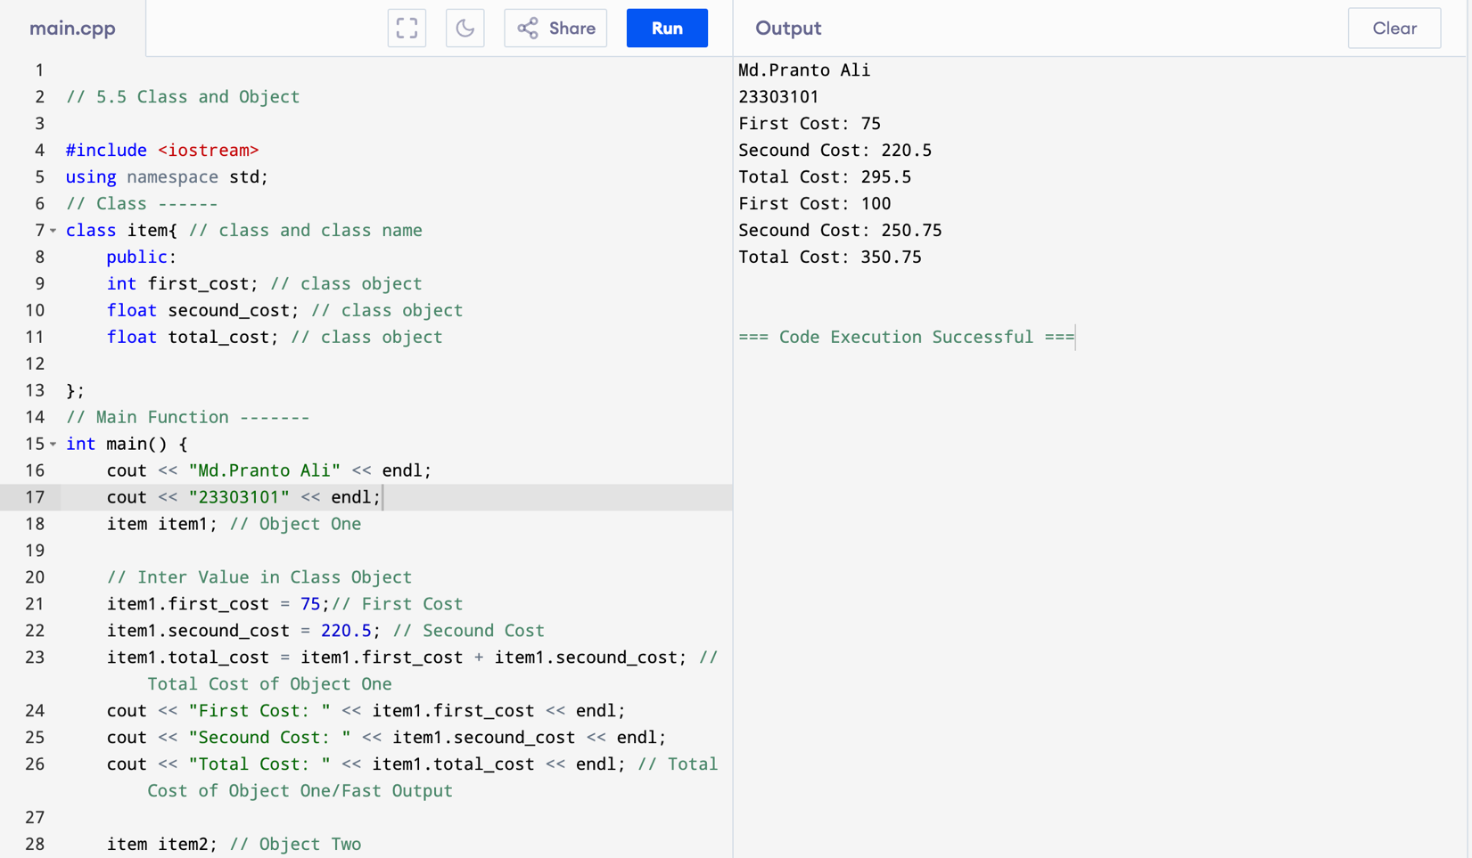

1. **Making an Outside Function Inline:**

1. **Nesting of Member Function:**

1. **Private Member Function:**

1. **Array within a Class:**

1. **Memory Alocation for a Object:**

1. **Array of Object:**

1. **Friend Function:**

1. **Class in a Array Student:**

1. **Dynamic Array Initialization:**

